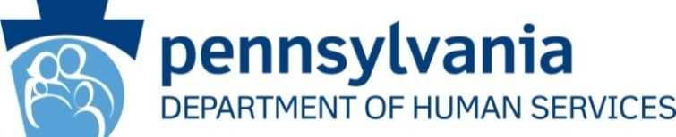
Statewide Adoption and Permanency Network and
Independent Living Services
2016 Spring Quarterly Meeting

Office of Children Youth and Families
Updates

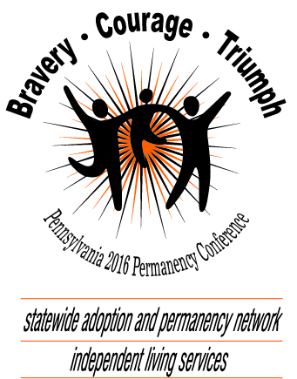

The 24th Annual Pennsylvania Permanency Conference:
June 15-17, 2016 is right around the corner and we hope to see you at Kalahari Resorts and Conventions in Monroe County, PA for what we expect to be our best conference yet!
Registration is now open and hotel rooms are booking fast! Find the brochure and link to register at http://www.diakon-swan.org and click on Events. Be sure to let your families know about this exciting location that includes an amazing indoor waterpark!

National Foster Care Month:
May is National Foster Care Month, a month set aside to acknowledge foster parents, family members, volunteers, mentors, policymakers, child welfare professionals, and other members of the community who help children and youth in foster care find permanent homes and connections. If you would like to have your event featured on the

SWAN Facebook page, please contact Joe Warrick at jwarrick@pa.gov or
(717) 214-6765.

National Youth In Transition Database:
National Youth in Transition Database (NYTD) implementation is ongoing with the Baseline Population (every youth in foster care who reaches age 17), the Served Population (any youth receiving an IL service regardless of age.), and the Follow-up 19 Population collection (period B starts April 1, 2016).

NYTD questions can be directed to Joe Warrick at jwarrick@pa.gov or (717) 214-6765.

Older Youth Retreat:
The 2016 Older Youth Retreat Steering Committee is busy making plans for another exciting event! Mark your calendars and save the dates for August 8-12, 2016. Once again, this popular week long retreat will be held at the University of Pittsburgh’s Johnstown Campus. Registration for youth will be coordinated through county children and youth agencies.

For more information about the Older Youth Retreat, visit: http://www.independentlivingpa.org or email Lisa Kessler at lkk20@pitt.edu.

PA Community on Transition Conference:
This year’s PA Community on Transition Conference, titled “Unlocking Potential: Promoting Strengths and Inspiring Success” will be held July 20-22, 2016 at the Penn Stater Conference Center. The primary purpose of this conference is to empower, educate and provide transition age youth with disabilities, and their families, the opportunity to learn about effective practices and resources that will enable them to explore and advocate for their future as they prepare for transition to adulthood. The conference also seeks to expand the capacity of schools, agencies and communities, which support these youth and their families, to obtain positive post-school outcomes of employment, post-secondary education and training, community participation and healthy lifestyles.

For more information about the conference or to learn about available scholarships for youth and families, visit: http://www.secondarytransition.org/event/565dd0cf140ba0225c8b45d0

Pennsylvania Chafee Education and Training Grant Program:
The Pennsylvania Chafee Education and Training Grant (ETG) application for the 2016-2017 school year and directions on how to apply are available online at: https://www.pheaa.org/funding-opportunities/other-educational-aid/chafee-program.shtml. The 2016-2017 maximum ETG award has yet to be determined (the amount per student in 2015-2016 was $4,750).

All current ETG award recipients will be automatically enrolled for the next
academic year and do not need to complete the ETG application. Free Application for Federal Student Aid (FAFSA) renewal forms must be completed every year.

For questions about current Chafee applications or a youth’s status, please contact PHEAA at 1-800-831-0797. If you have questions regarding the ETG program, contact Joe Warrick at jwarrick@pa.gov or at (717) 214-6765.

SWAN Google Groups:
The SWAN ListServ through Google Groups is comprised of county children and youth agency workers and SWAN affiliate agency workers. The goal of the group is to facilitate special needs adoptions throughout PA. All information posted on this site is confidential. Anyone wishing to join this group must be an employee of a county children and youth agency or SWAN affiliate agency. If interested, please contact Joe Warrick by email at jwarrick@pa.gov or at (717) 214-6765.
SWAN-IL Network Newsletter:
Tell the Network about all of the wonderful things you, your agency, your community, a youth or a colleague are doing to promote improved outcomes for PA’s foster youth. If you have something exciting, interesting or informative to share with your colleagues, please forward your articles, success stories, matching events or ideas to Karen Lollo at klollo@diakon-swan.org or at (717) 558-1242. Pictures are always a great addition to any article. You can find the latest and past editions of this newsletter at www.adoptpakids.org under the Network Newsletter link.

Western PA Matching Event:
OCYF, in partnership with National Adoption Center, is pleased to announce the Older Youth Matching Event at Camp Agawam, in western Pennsylvania on Saturday, June 11, 2016. This event is a fun, interactive day where prospective adoptive families and older youth in need of a permanent home can get acquainted with one another.

To register, visit www.adopt.org/events or contact Julie Marks at pateen@adopt.org or (267) 443-1875.

Child and Family Services Review (CFSR):
Did you know Pennsylvania is scheduled to participate in the 3rd round of federal Child and Family Services Reviews (CFSR) beginning in the spring of 2017? The CFSR is a federal-state collaborative effort designed to help ensure that quality services are provided to children and families through state child welfare systems. These reviews examine state child welfare programs and practice to identify strengths and challenges in state programs and systems, focusing on outcomes for children and families in the areas of safety, permanency and well-being. In advance of the onsite review, states are required to submit a Statewide Assessment that is developed in collaboration with system partners. To inform the Statewide Assessment, PA will be conducting focus groups and administering surveys to various stakeholders across the state during 2016. Stay tuned for announcements about potential opportunities to provide feedback through these focus groups and surveys.

Continuous Quality Improvement:
Round 6 of the Quality Service Reviews (QSRs) are currently underway. QSRs are a great opportunity to see county practice in action and to interact with the children and families we serve from a different perspective. Those who have participated as a reviewer in the past only need to complete the
QSR Refresher session, which is generally held via WebEx. The current calendar of onsite reviews and training dates for the 2016 QSRs are as follows:

- Snyder QSR: 5/10/16 – 5/12/16
2 day training: 4/13/16 – 4/14/16. Refresher session: 4/20/16 (time is TBD)

- Crawford QSR: 5/17/16 – 5/19/16 and 5/24/16 – 5/26/16. 2 day training: 4/18/16 – 4/19/16. Refresher session: 4/20/16 from 9:30am-11:30am

- Wyoming QSR: 6/8/16 – 6/10/16. 2 day training and Refresher Session dates: TBD

- Clarion QSR: TBD

- Philadelphia QSR: TBD

Anyone interested in signing up to be a potential QSR reviewer can do so by filling out the online QSR Reviewer Application located on the CWRC website: http://www.pacwrc.pitt.edu/QSR-app.asp. If anyone has any questions regarding any of the reviews, please feel free to contact Natalie Perrin at nperrin@pa.gov or (717) 783-7376.

/adoptpa
/adoptpakids
www.adoptpakids.org

