Instructions for Receiving Secure Email from SWAN Prime Contractor

- This applies to messages sent from the SWAN Prime Contractor to an external (non dialon-swan.org) email address. Message appears in Inbox.
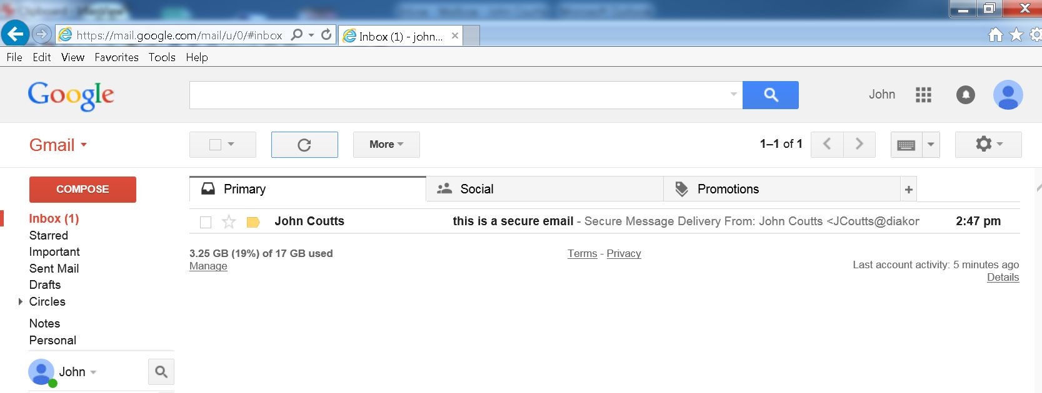
- Open message then click View Message.
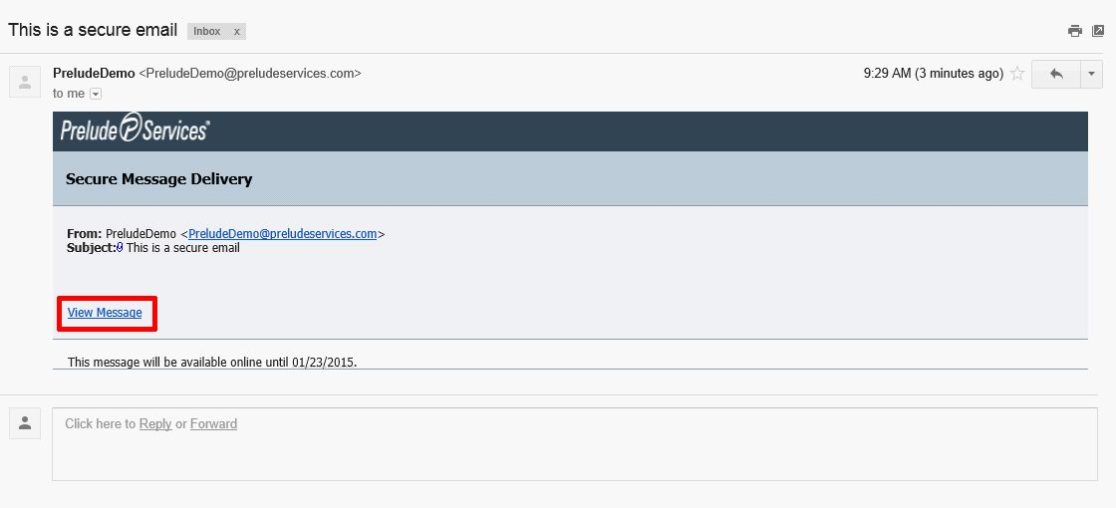
- Message opens in a new browser tab.

- Use Reply or Reply All to respond to message as displayed below. DO NOT use email site’s reply function to respond.
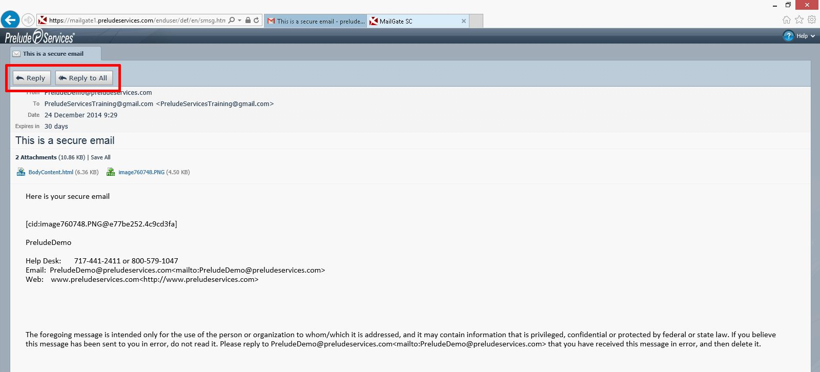
- The message will expire 30 days after it has been received. If you will need this information for more than 30 days, please save the message/attachments to an external location.

